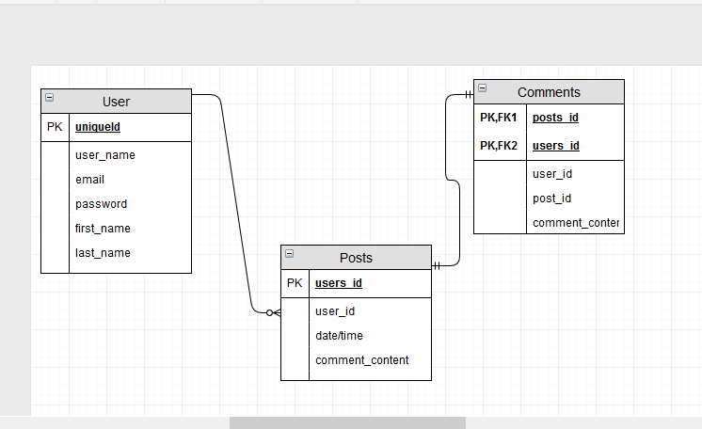

CREATE DATABASE IF NOT EXISTS SocialMediaDB;

USE SocialMediaDB;

DROP TABLE IF EXISTS users;

DROP TABLE IF EXISTS posts;

DROP TABLE IF EXISTS comments;

CREATE TABLE users (

id int(11) NOT NULL auto_increment,

user_name varchar(30) NOT NULL,

email varchar(25) NOT NULL,

password varchar(15) NOT NULL,

first_name varchar(20) NOT NULL,

last_name varchar(20) NOT NULL,

PRIMARY KEY (id)

);

CREATE TABLE posts (

id int(11) NOT NULL auto_increment,

user_ID int(11) NOT NULL,

date datetime default current_timestamp,

post_content varchar(200),

PRIMARY KEY (id),

FOREIGN KEY (user_ID) REFERENCES users(id)

);

CREATE TABLE comments (

id int(15) NOT NULL auto_increment,

post_ID int(15) NOT NULL,

user_ID int(15) NOT NULL,

date datetime default current_timestamp,

comment_content varchar(200),

PRIMARY KEY (id),

FOREIGN KEY (post_ID) REFERENCES posts(id),

FOREIGN KEY (user_ID) REFERENCES users(id)

);